**Emotions:**

**1. Definition and Components of Emotions**

Imagine you're watching a movie.

* **Subjective Experience:** The movie genre decides how you feel—romantic for love, thriller for fear, or comedy for happiness.
* **Physiological Response:** Your body reacts—heart races during suspense, tears during heartbreak.
* **Behavioral Expression:** You laugh at jokes, gasp at twists, or cry during sad scenes.

Emotions are your brain and body’s collaborative production, like a film that tells a story through reactions.

**2. Basic vs. Secondary Emotions**

Think of **basic emotions** as primary colors (red, blue, yellow)—universal, fundamental, and visible everywhere.

* **Red:** Anger.
* **Blue:** Sadness.
* **Yellow:** Happiness.

**Secondary emotions** are like blended colors, unique shades influenced by your personal life. Frustration might be anger mixed with sadness, while pride is happiness shaded with accomplishment.

**3. James-Lange Theory**

**Metaphor:** Your body is the stage manager for your feelings.

* Imagine walking in a spooky forest.
* First, you hear a rustling in the bushes (situation).
* Your heart pounds, and you start to sweat (physiological response).
* Then, you realize, “I’m scared!” (emotion).

It’s like realizing you’re scared because your body sounded the alarm first.

**4. Cannon-Bard Theory**

**Story:** Imagine you’re a fire alarm that rings and sprays water at the same time.

* A fire breaks out (situation).
* You feel fear (emotion) and your body starts sweating (physiological response) **simultaneously**.

Your brain handles both the alarm and the sprinklers together—it doesn't wait for one to trigger the other.

**5. Schachter-Singer Theory**

**Metaphor:** Think of your emotions as mystery novels.

* You’re at a surprise party, and your heart races when everyone yells “Surprise!” (physiological arousal).
* You look around and piece together the decorations, cake, and faces (cognition).
* Finally, you decide, “I’m happy!” (emotion).

Without interpreting the clues, you wouldn’t know how to feel. Your brain needs to solve the puzzle to name the emotion.

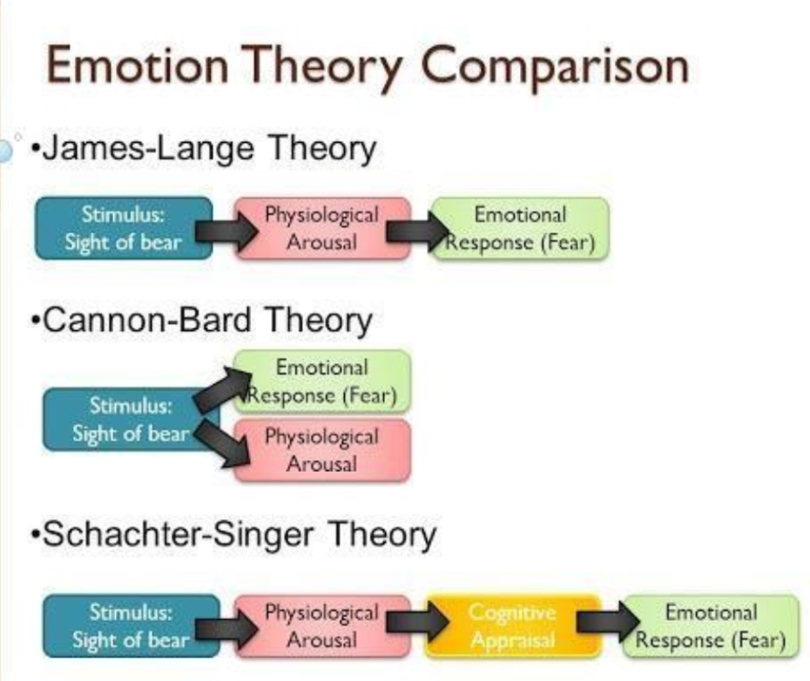

**6. Impact of Emotions on Health**

Imagine your emotions are a garden:

* **Happiness** is sunshine—making everything bloom and thrive.
* **Chronic sadness** is like weeds, choking the plants if left unchecked.
* **Anger** is a storm—it can uproot everything if not managed properly.

Tend to your emotional garden to grow a healthy, vibrant life.

**7. Positive and Negative Emotions**

Emotions are like the weather.

* **Positive emotions** are sunny days that motivate you to go outside, explore, and thrive.
* **Negative emotions** are storms—they might slow you down, but they’re part of nature and help you appreciate sunny days even more.
* **Detailed Notes:**

**1. Nature of Emotions**

* **Etymology:** The term *emotion* comes from the Latin word *emovere*, meaning "to stir, agitate, or move."
* **Definition:**
  + Emotions are stirred-up states involving physical and psychological changes that influence thoughts and behavior.
  + According to the American Psychological Association (APA), emotions involve experiential, behavioral, and physiological elements.
  + Components of emotion include:
    - **Subjective Experience:** Personal feelings or reactions.
    - **Physiological Response:** Bodily reactions like increased heart rate or sweating.
    - **Behavioral Expression:** Outward expressions such as smiling or crying.

**2. Basic Emotions**

* Proposed by psychologist **Paul Ekman (1972):**
  + Six universal emotions: **Fear, Disgust, Anger, Surprise, Happiness, and Sadness.**
* Expanded list (1999):
  + Added emotions like **Embarrassment, Excitement, Contempt, Shame, Pride, Satisfaction, and Amusement.**

**3. Classification of Emotions**

* **Primary Emotions:**
  + Universal emotions experienced across all cultures (e.g., Happiness, Sadness, Anger, Fear).
* **Secondary Emotions:**
  + Variations of primary emotions influenced by context or personal experiences (e.g., Frustration, Envy, Pride).
  + Often arise as reactions to primary emotions (e.g., Feeling frustrated because of sadness).

**4. Forms of Emotions**

* **Positive Emotions:**
  + Pleasant to experience and motivational (e.g., Happiness, Excitement, Pride, Satisfaction).
* **Negative Emotions:**
  + Unpleasant emotions that may disrupt life but are part of the natural emotional spectrum (e.g., Envy, Anger, Fear, Sadness).

**5. Impact of Emotions on Health**

* **Negative Effects:**
  + Chronic fear → Linked to anxiety, inflammation, and lowered immunity.
  + Chronic sadness → Associated with poorer physical health.
  + Anger → Related to heart disease and risky behaviors like smoking.
* **Positive Effects:**
  + Happiness → Linked to a longer lifespan.
* **Takeaway:** It’s healthy to experience all emotions, but finding productive ways to express them is crucial for maintaining mental and physical health.
* 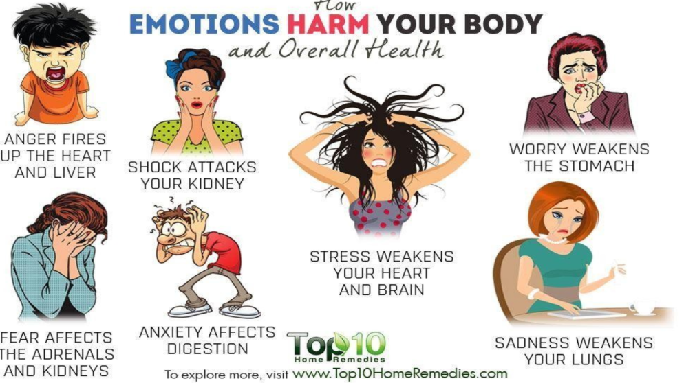

**6. Theories of Emotion**

**a. James-Lange Theory**

* Proposed by **William James** and **Carl Lange.**
* **Core Idea:** Emotions are the result of physiological responses.
* **Mechanism:**
  1. Stimulus → Physiological reaction (e.g., trembling, heart racing).
  2. Physiological reaction → Emotional experience.
  3. Example:
     + Situation: Sitting alone in a dark room and hearing a sound behind you.
     + Physiological Response: Heart races and trembling begins.
     + Emotion: You interpret these as fear.

**b. Cannon-Bard Theory**

* Proposed by **Walter Cannon** and **Philip Bard.**
* **Core Idea:** Emotional experience and physiological response occur simultaneously.
* **Mechanism:**
  1. Stimulus triggers both emotion and physical reaction at the same time.
  2. Example:
     + Situation: Alone in a dark room and hear a sound.
     + Simultaneous Experience: You feel fear while your body reacts with a racing heart and trembling.

**c. Schachter-Singer Theory**

* Also known as the **Two-Factor Theory of Emotion.**
* Proposed by **Stanley Schachter** and **Jerome Singer.**
* **Core Idea:** Emotions are a combination of physiological arousal and cognitive interpretation.
* **Mechanism:**
  1. Stimulus → Physiological arousal.
  2. Cognitive interpretation → Labeling of the emotion.
  3. Example:
     + Situation: Mark is at a surprise party.
     + Physiological Arousal: Heart races due to loud noises and excitement.
     + Cognitive Labeling: Mark sees decorations and realizes it’s a party.
     + Emotion: He interprets his arousal as excitement and happiness.

**Summary of Theories**

* **James-Lange:** Emotions follow physiological reactions.
* **Cannon-Bard:** Emotions and physical responses occur simultaneously.
* **Schachter-Singer:** Emotions arise from a mix of arousal and reasoning.